Personal Portfolio Wai Tai Chong N9291695

For release 1 of our project – media vault, I have contribute parts of the coding, and also testing.

1. **Searching features**

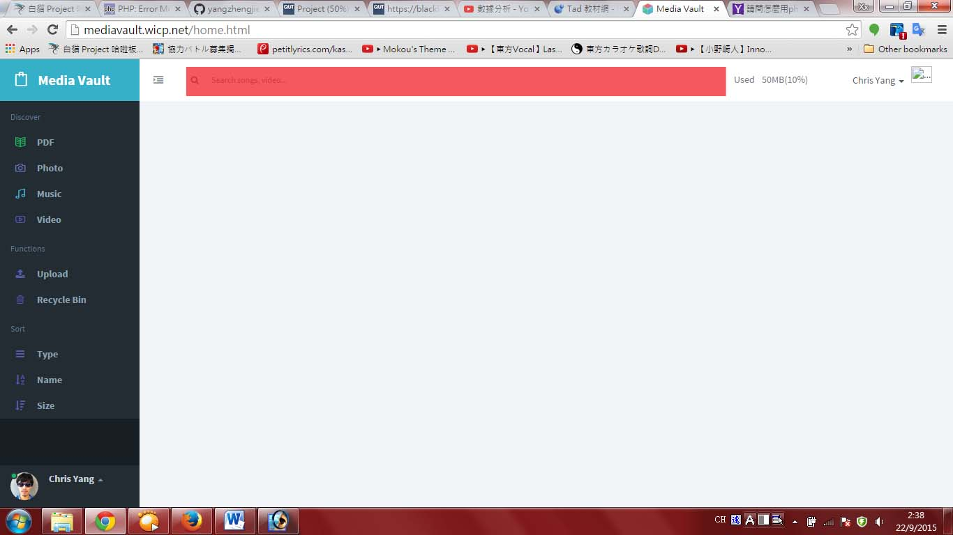

**Figure 1.1**

Figure 1.1 shows the searching bar (in red) is on the top of home page. Users can type key words about any media files, after that the result will be shown in the content page. Figure 1.2 shows how it works.

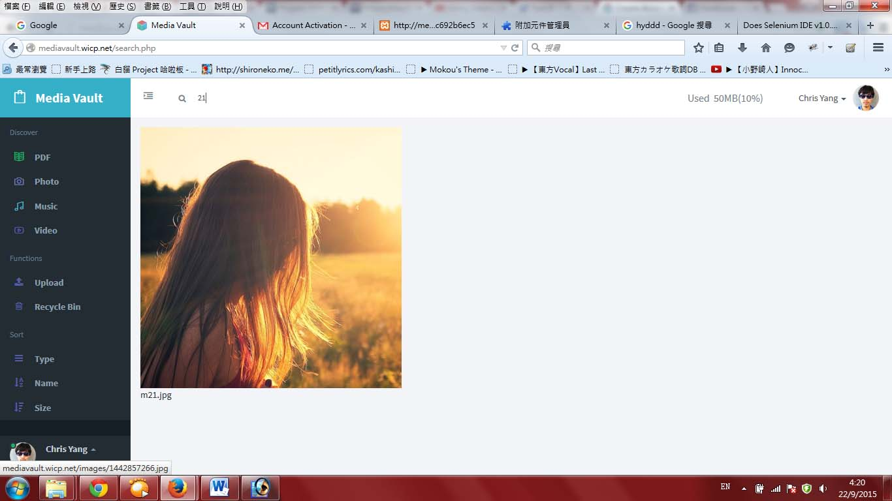

**Figure 1.2**

If users do not type any key word and then press the search button, script box will come out and alert users that they have to enter something to search. (Figure 1.3)

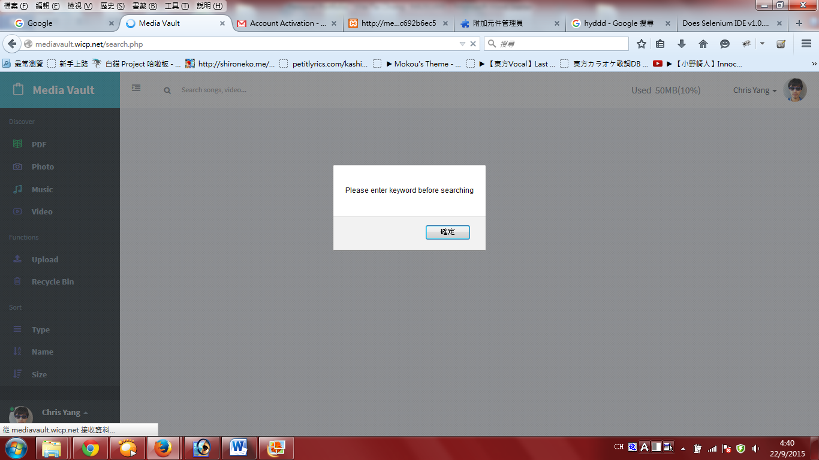

**Figure 1.3**

If users search the key words that our database does not exist. No result will be shown to user. (Figure 1.4)

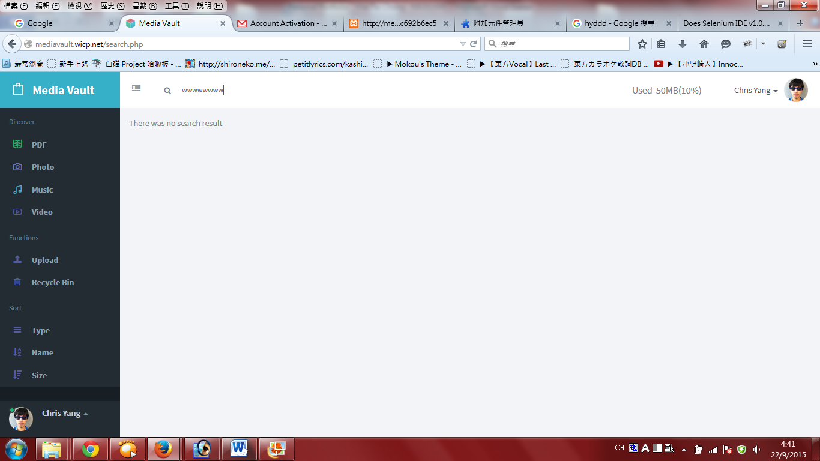

**Figure 1.4**

1. **Uploading Music Files**

Figure 2.1 shows the uploading pages.

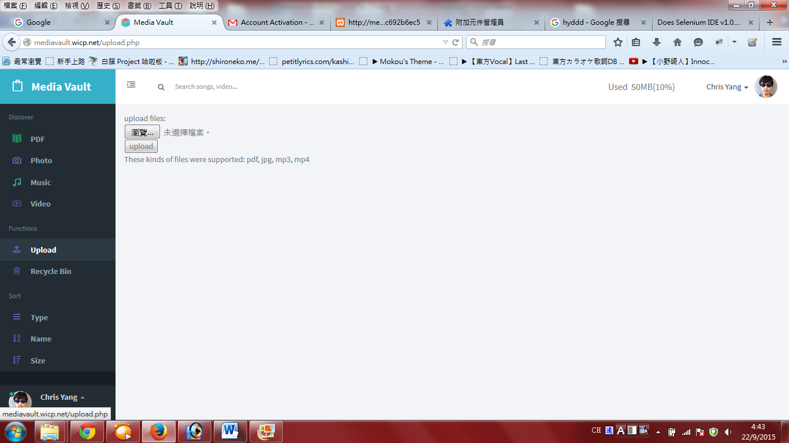

**Figure 2.1**

Press browse and choose the music file user wants to upload. (Figure 2.2) Right hand side will show the file name to confirm it is extracted correctly. (Figure 2.3) Press ‘upload’ button to upload. If it is success, it will show like Figure 2.4.

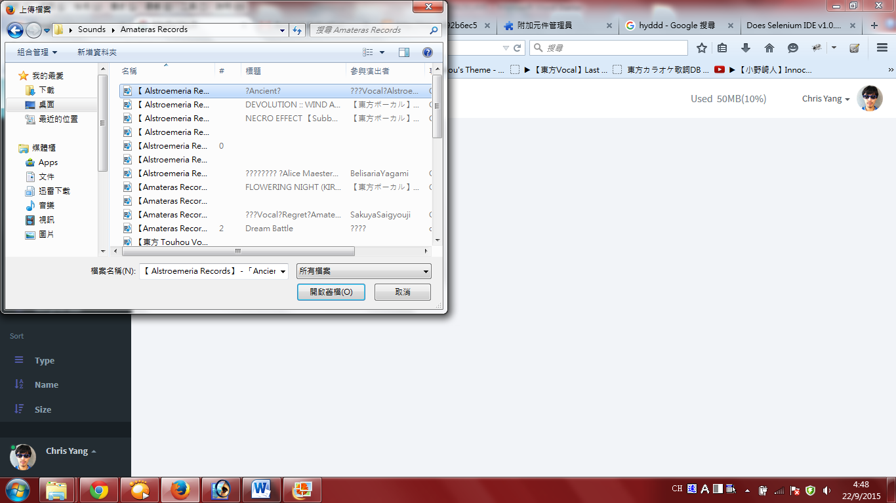

**Figure 2.2**



**Figure 2.3**

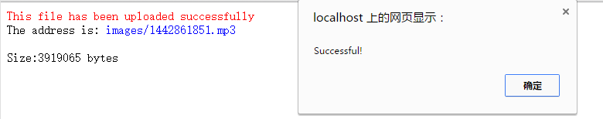

**Figure 2.4**

1. **Music Page (Accessing)**

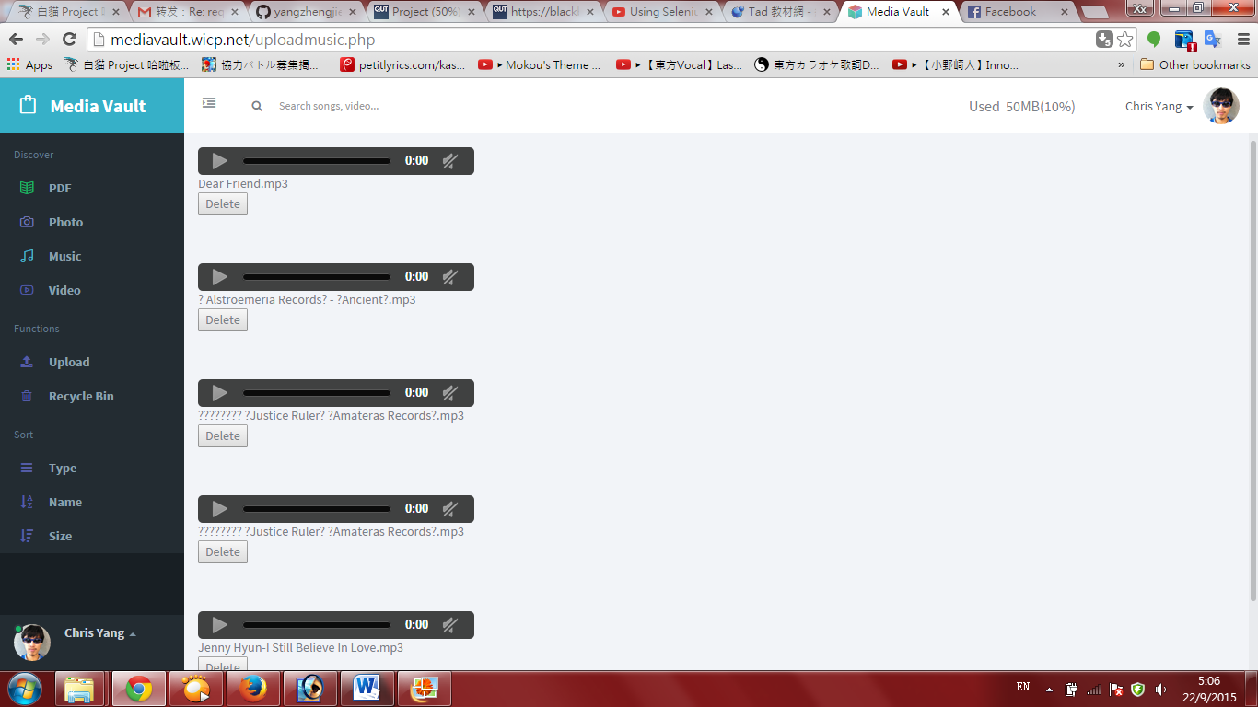

**Figure 3.1**

Figure 3.1 is the page that showing all the music files (.mp3/.mp4) from database. Users can play them online and also download also.

1. **Music Page (Delete Files)**

Figure 3.1 also shows a delete button which users can press it to delete music files. After deleting, a script box will show to alert user t

T the files are deleted successfully. (Figure 4.1)

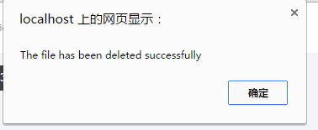

**Figure 4.1**

**5. Testing for Register, Login and Password recovery features**

**5.1 Register**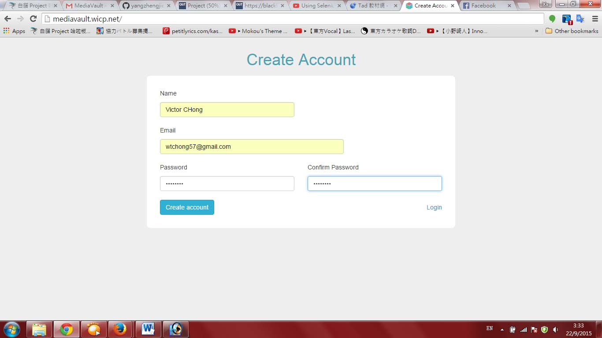

**Figure 5.1.1**

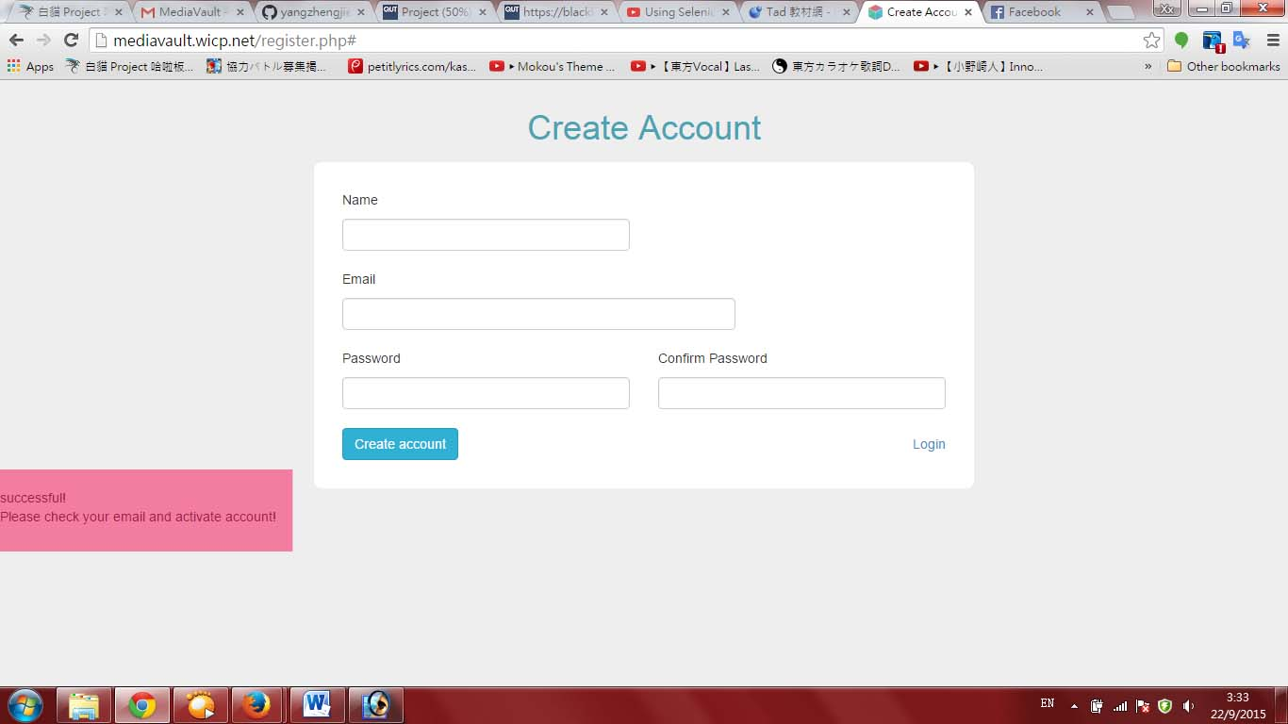

**Figure 4.1.2**

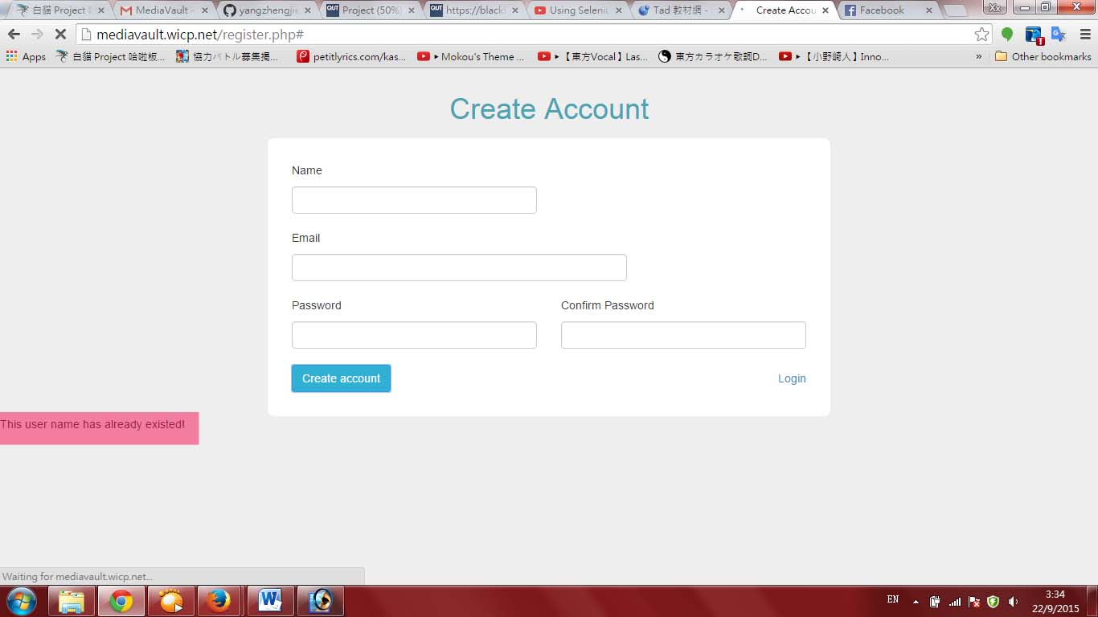

**Figure 5.1.3**

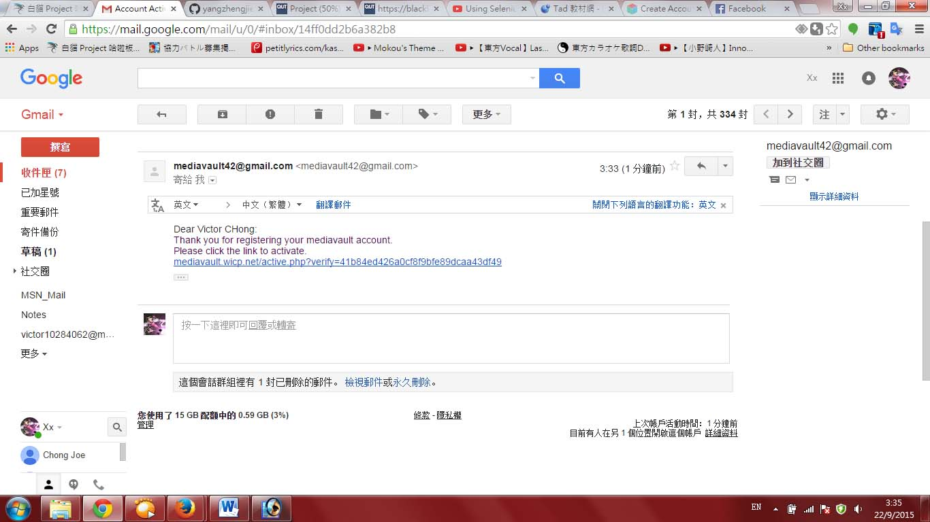

**Figure 5.1.4**

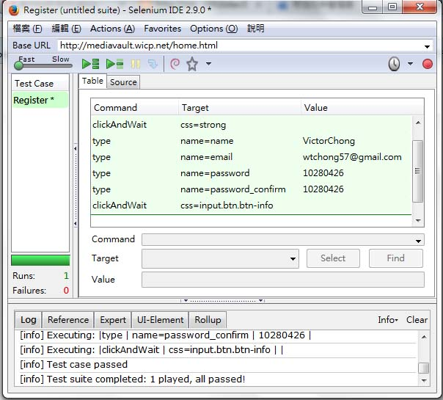

**Figure 5.1.5**

**5.2 Login**

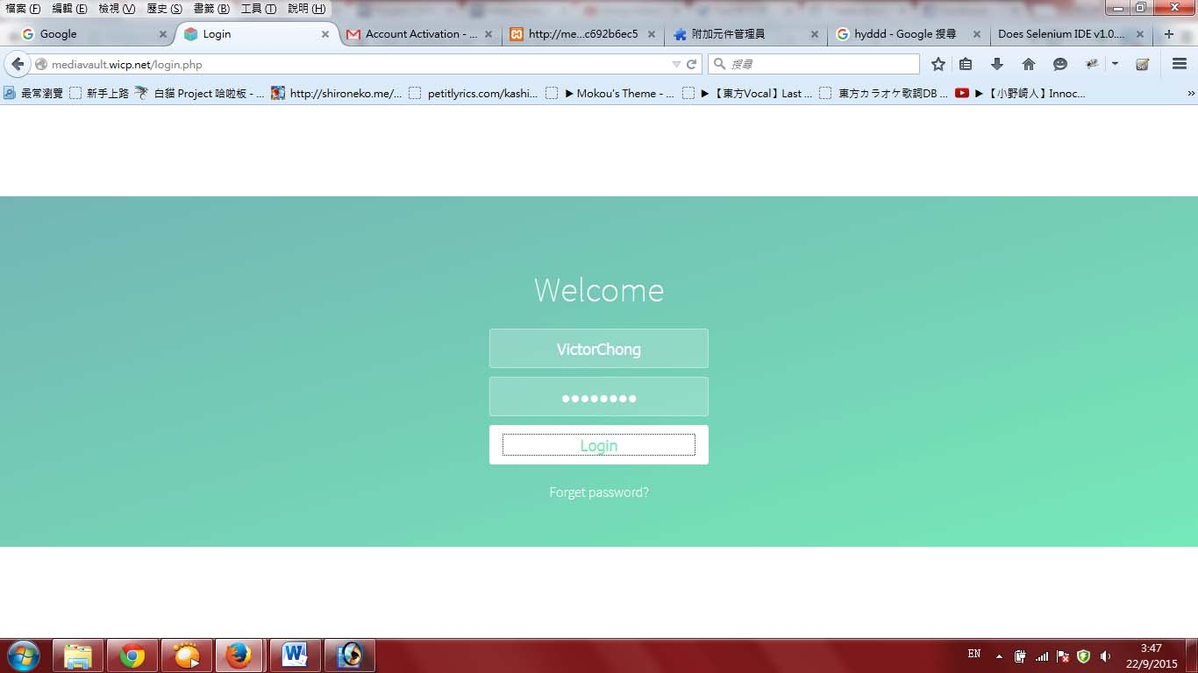

**Figure 5.2.1**

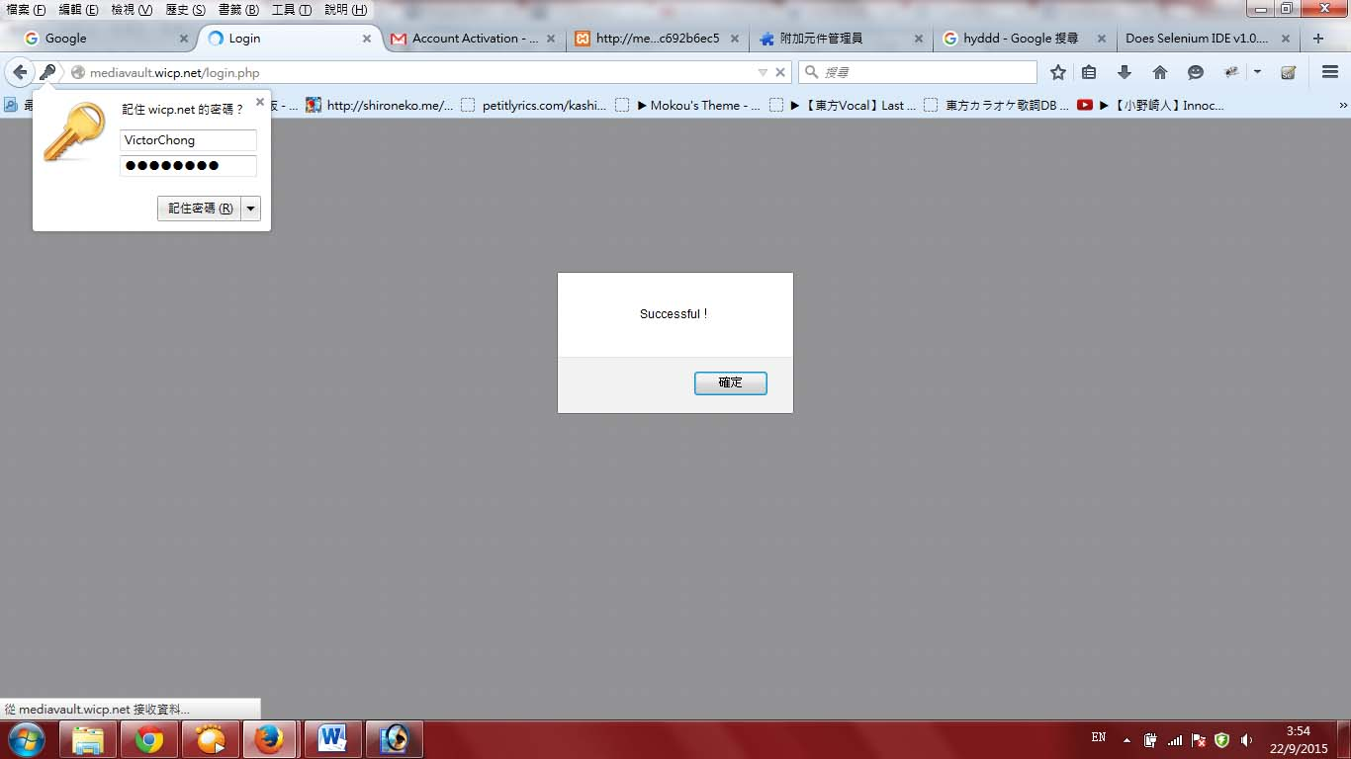

**Figure 5.2.2**

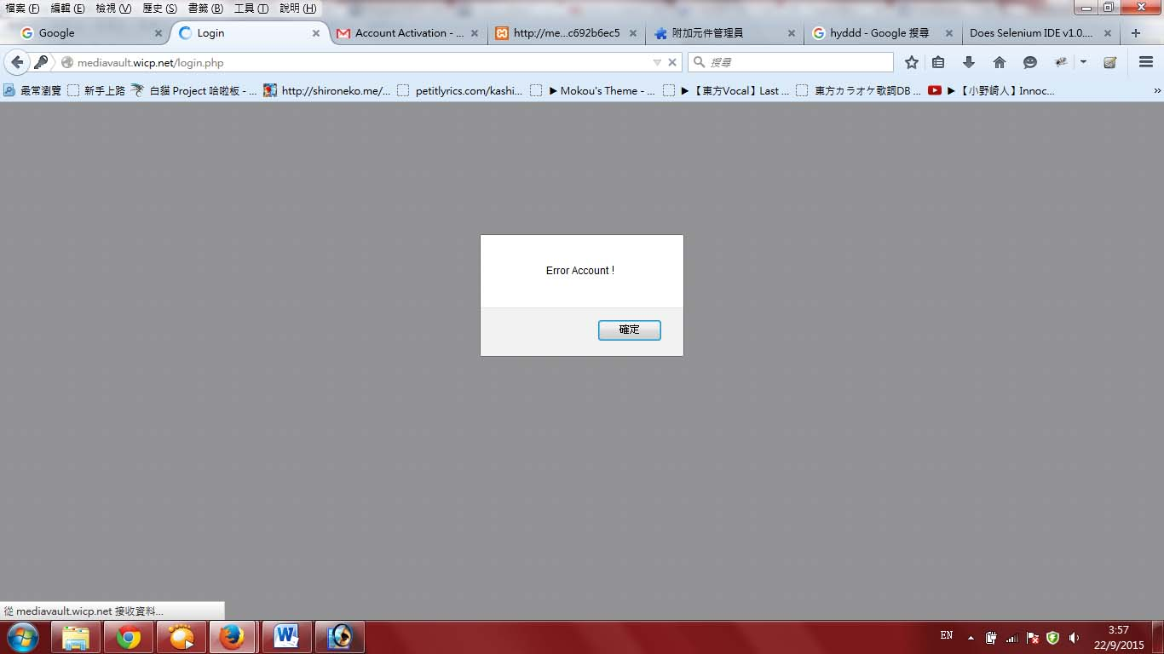

**Figure 5.2.3**

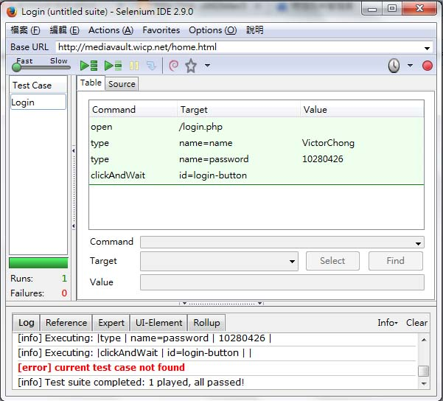

**Figure 5.2.4**

**4.3 Password recovery**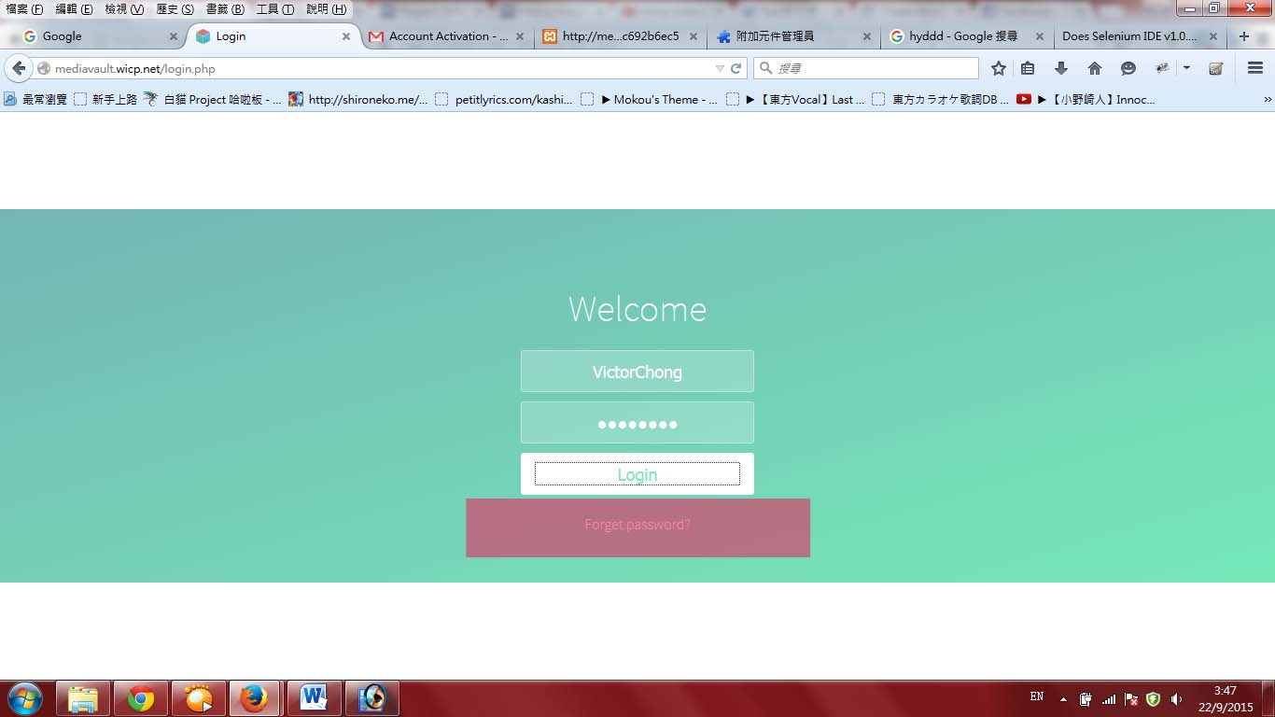

**Figure 5.3.1**

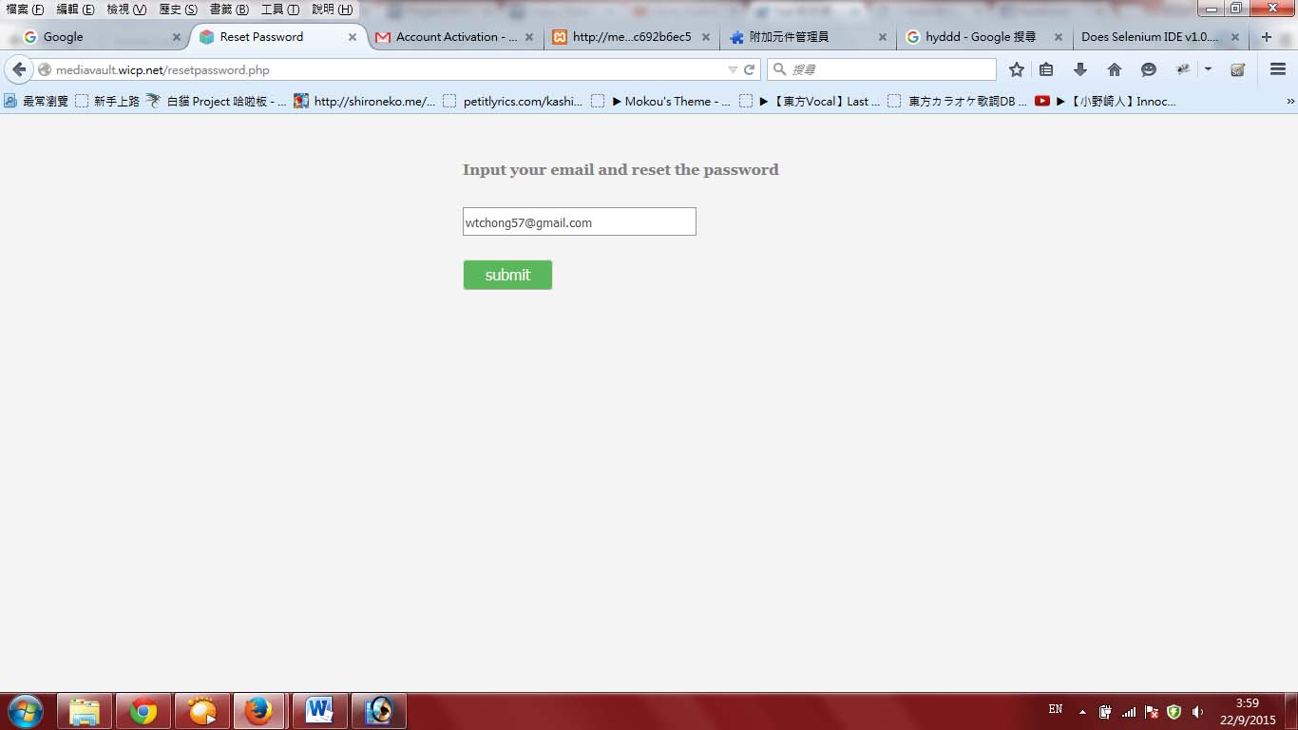

**Figure 5.3.2**

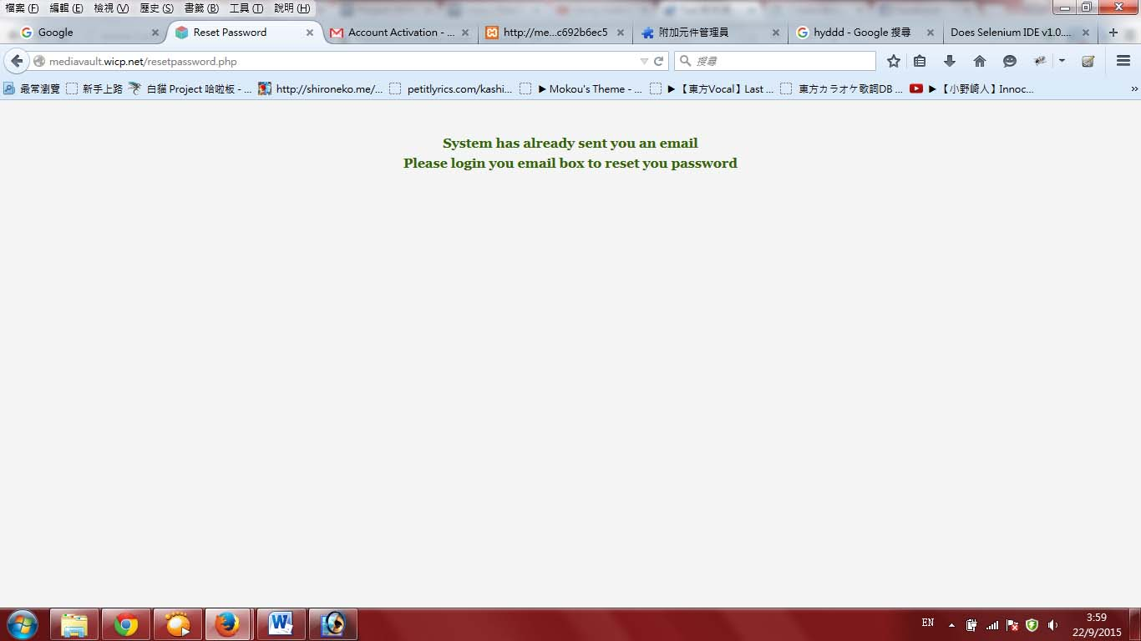

**Figure 5.3.3**